EXERCISE Week 08: Context Scenarios and IA

**Due:**  November 07, 2019 by 11:59pm

**Points:** 10

**Submitting:**  a file upload

**File Types** pdf

This will be a part of DP1 so expect to iterate on this.

**Overview**

You are asked to prototype the interaction for people to purchase goods or services from a peer-to-peer service (think craigslist) through a native mobile application. Use the requirement of it being a native app as an opportunity to take full advantage of platform capabilities such as GPS, camera, bluetooth, etc.

**What you will be doing**

You will focus on creating several scenarios which will be driven by the [persona and context you are given (Links to an external site.)](https://drive.google.com/open?id=12IfuGJG095WOLcIdPM7Iq9FCdiA9umBQqRQkmm_Si90). Document the scenarios you come up with as a contextual scenario or a storyboard. Think beyond browsing. Think about how to arrange a safe meeting location for delivering items for sale. Think about ways to pay for items after seeing the actual product. Think about returns or leaving seller feedback. Remember: They should **not** describe product or interaction detail, but rather focus on high-level actions from the user’s perspective.

Based in these scenarios, secondary tasks, and tertiary tasks (e.g. leaving app feedback) define an information architecture. Identify all pages, flows for subtasks that make sense (e.g. onboarding), and navigational paths between them. Identify primary and secondary paths. This can be in the form of a site-map.

Create a flow diagram for each scenario, covering the "happy path," decision points (that may exist outside of the app), points of failure, and escape hatches.

**What to turn in**

Upload a single pdf containing the following:

* Document the persona and the context you are given
* Identify 5 key scenarios that your persona is most likely to find themselves in. Document them via context scenario or as storyboards.
* Include one flow diagram for each scenario with various paths including a clear "happy path"
* Show an app-wide information architecture

Rubric

**Some Rubric**

| Some Rubric | | |
| --- | --- | --- |
| **Criteria** | **Ratings** | **Pts** |
| This criterion is linked to a Learning OutcomeIdentify 5 key scenarios | |  |  | | --- | --- | | **2.0 pts**  **Full Marks** | **0.0 pts**  **No Marks** | | 2.0 pts |
| This criterion is linked to a Learning OutcomeApp-wide information architecture | |  |  | | --- | --- | | **3.0 pts**  **Full Marks** | **0.0 pts**  **No Marks** | | 3.0 pts |
| This criterion is linked to a Learning OutcomeA flow diagram for each scenario | |  |  | | --- | --- | | **5.0 pts**  **Full Marks** | **0.0 pts**  **No Marks** | | 5.0 pts |
| Total Points: 10.0 | | |

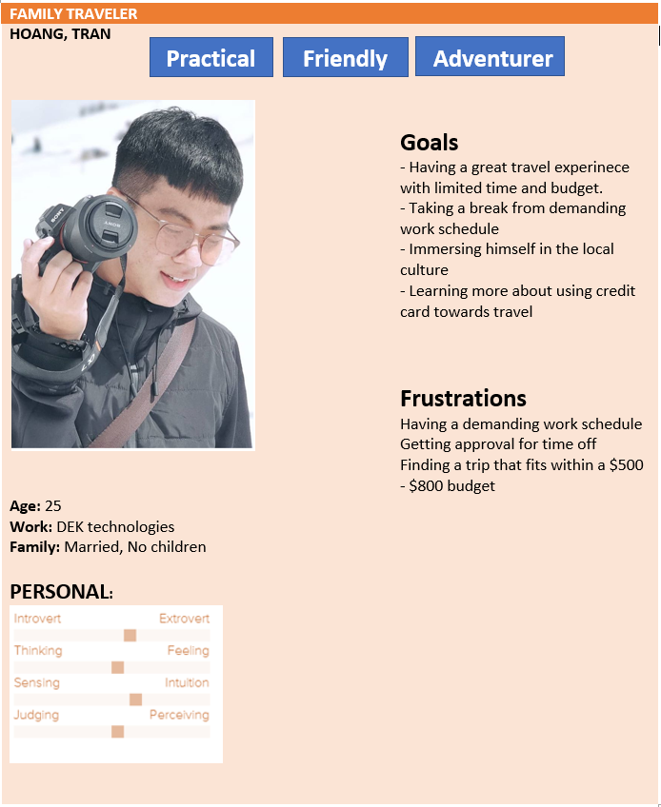

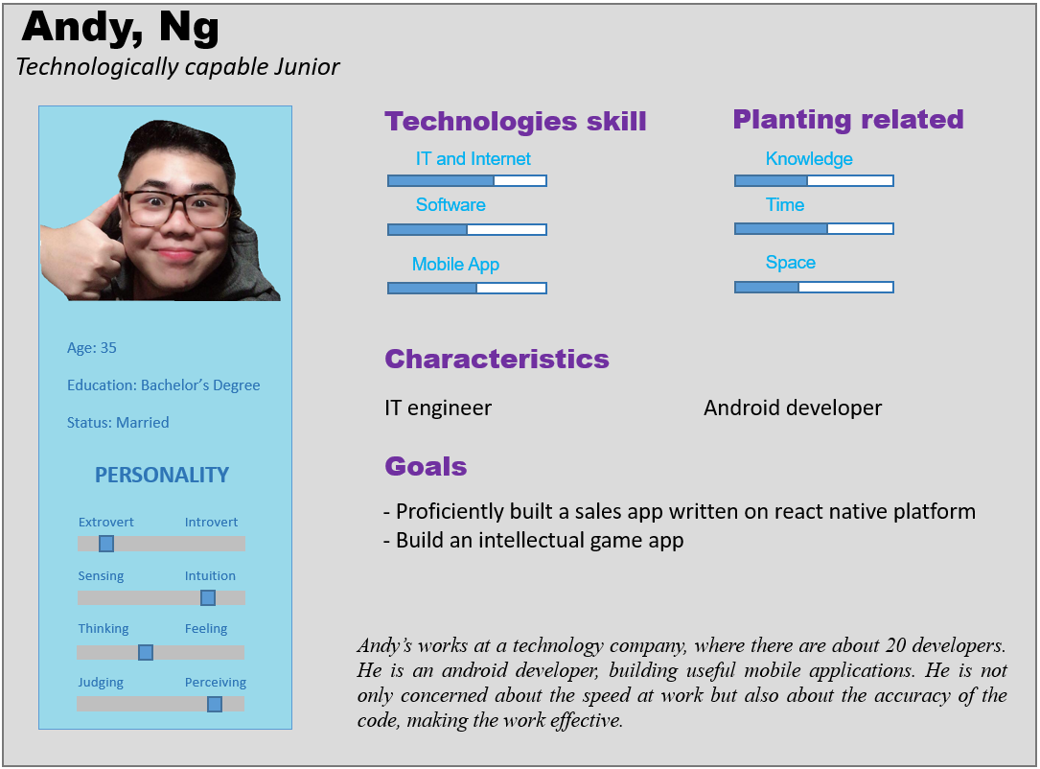



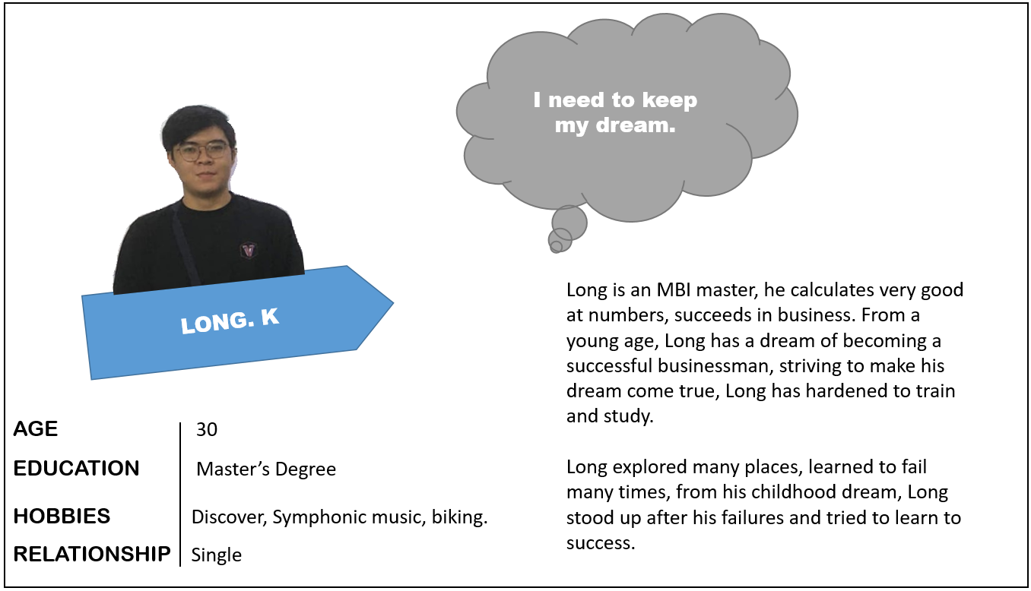

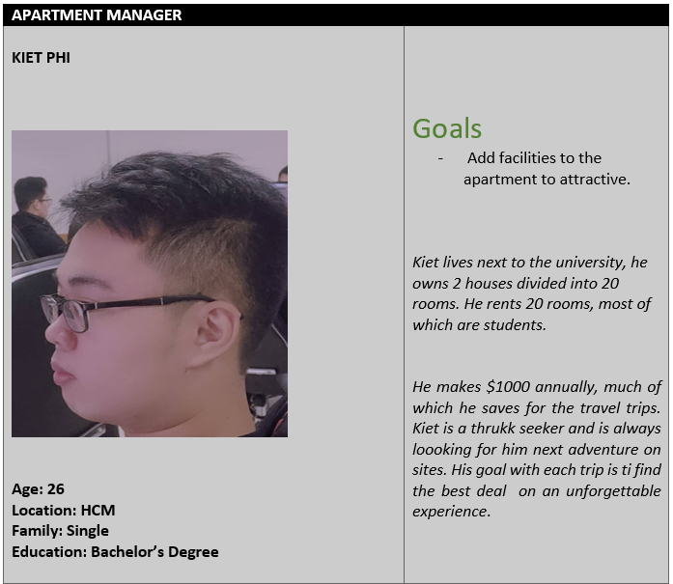

**Hoang, Tran**: Hoang is a young engineer, 25 years old, married. He likes to explore many places with little savings money. So he’s looking for the trip that fits within 500 - $800 budget.

**Andy, Nguyen**: Andy is 35 years old, an experienced IT engineer, his daily work is proficiently built a sales app written on react native platform or build an intellectual game app. He has almost no special hobbies, rarely traveling with his family

**Quoc, Nguyen**: Quoc is a guy who just graduated from university, like to explore and conquer many places. He loves to take photos and likes to go hiking, he took beautiful sets of photos of the places he went. He just graduated and traveled a lot, so he is still unemployed.

**Long, Kim**: Mr Kim is a successful businessman, he has dreamed from becoming a rich man since childhood. However, he is still single, unable to find the right person

**Kiet, Phi**: Kiet owns 20 rooms for students to rent, he uses the money he earned to travel with his family.

**Scenario 1: Hoang’s looking for the trip with budget $500**

Hoang really like travel, he wanna explore many places, so he spend the amount of his money, but now Hoang realized he had wasted money on shopping and luxury travel. He decided to plan the trip with the budget $500 for all member on his family. So he search some trip on an app, and book the flight tickets, hotel, and some ideas for the trip by the app’s suggestion. First, he looks for a convenient area, the time and price, after that, he will search the flight and hotel around the places. But almost ticket or hotel price is so higher than the money he has. So he waiting for the sale period. He decided to add some ticket and some hotel he like at the wishlist, and wait for the sale period. Then, he will pay and prepare for the vacation.

**Scenario 2: Andy is sick and have to stay at hospital**

One day, Andy felt unwell and headache, unable to eat. He decided to go to the hospital and the doctor said he needed to be hospitalized for treatment and care. Andy's illness is due to the fact that he spends 12 hours at work and doesn't have a proper diet, doesn't exercise properly. He hardly ever travels with his family on vacation of the year. He focuses on working throughout the year without a break. Despite his success at work, he fell ill.

After the treatment, he was determined to rest and spend more time with his family.

After finding out an app that suited his and his family's needs, he decided to create an account and book a flight, hotel for his vacation. The app has a lot of choices for airlines and hotels, and there's a wide range of prices. Can pay online, without paying any extra fees.

**Scenario 3: The camera is broken and there is not enough money to repair it**

Quoc is a graduate student, so he spends all his time exploring many places and taking photos. Quoc has a hobby of taking photos but he still hasn't made any money from it. Quoc realized that he still had not found a job and still asked for money from his parents.

One day, Quoc's camera broke down, he couldn't take it with this lens, Quoc could borrow you but he still didn't have a job so he couldn't pay it. Quoc thinks he should find a job, support his parents and be able to shop according to his needs.

So he searched the shop for camera lenses through the app, he could order them online and be delivered to home. There are many types of prices on the app and many shops. However, Quoc meet the shop have a bad service, he search again, and finally, he can find the shop with a good and profession service, the shop that have price, but Quoc do not have enough money, so from there Quoc can know he save how much enough money to buy.

**Scenario 4: The charity trip has changed the preconception about girls**

Mr. Kim is a successful man, with material conditions and money. However, he is still not married. He wanted to marry a beautiful and suitable woman for him because he thought women come to him for money, don't love him truly.

One day, Mr.KIm is guided by his friend to use the dating app, he will create an account, introduce himself and will have the opportunity to find the people he thinks are right for him. Then will exchange information through the message, and exchange phone numbers, then if you feel appropriate will meet in real life. But he had to pay when using the app, when he found a suitable person, he had to pay the app a set amount of money. Mr. Kim found a woman, talking for several months, a divorced woman about 30 years old. Then Mr. Kim and his company colleagues organized a charity event for poor children. She is a volunteer, with a pure heart and compassion. One day, Mr. Kim and his company colleagues organized a charity event for poor children. During the trip, there was a divorced woman about 30 years old. She is a volunteer, with a pure heart and compassion.

**Scenario 5:**   
Kiet is the owner of 20 rooms for rent, he used the money he earned to travel. However, he received a few complaints that the room was downgraded, not worth the rent.

He decided to upgrade and repair those 20 rooms, which is beautiful to please his customers, and he also feels happy when his rooms are clean and spacious.

Kiet decided to order the necessary things when upgrading the room. He is just looking for keywords in the app, the app will suggest and give him the variety he needs. Then he just needs to choose and order. App with delivery function, online payment or cash. Kiet does not need to go to many stores and is not afraid of missing items

* Include one flow diagram for each scenario with various paths including a clear "happy path"

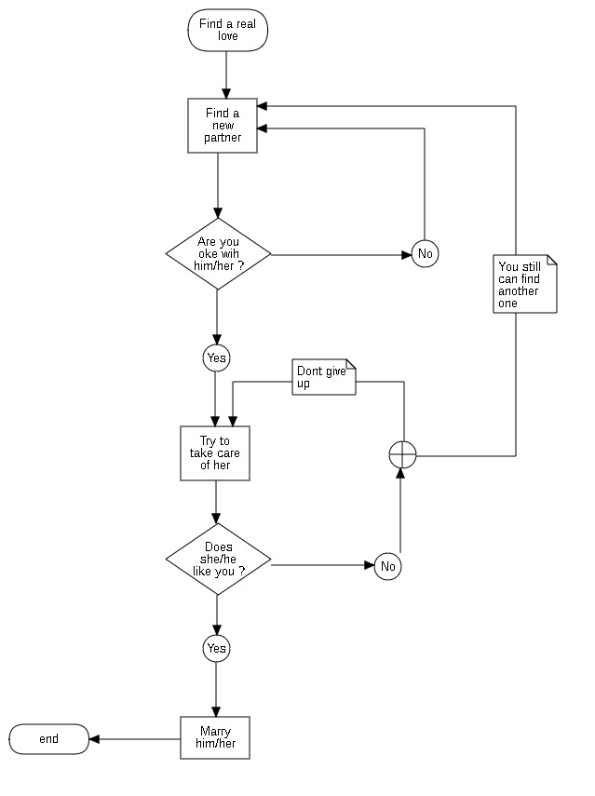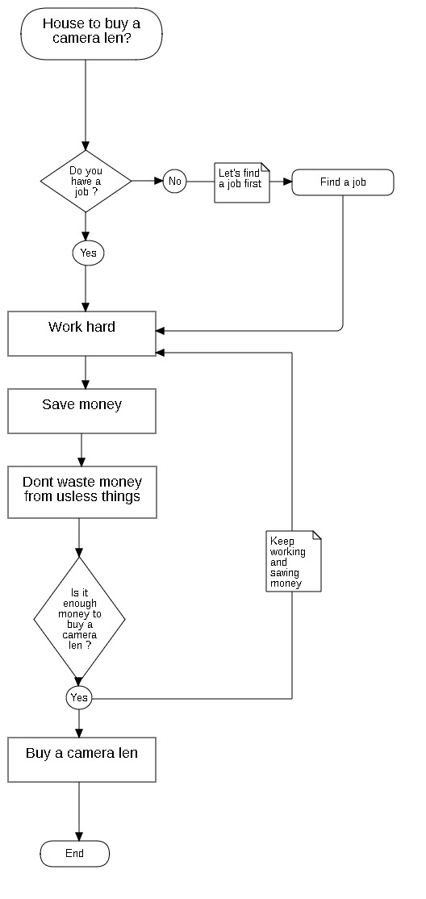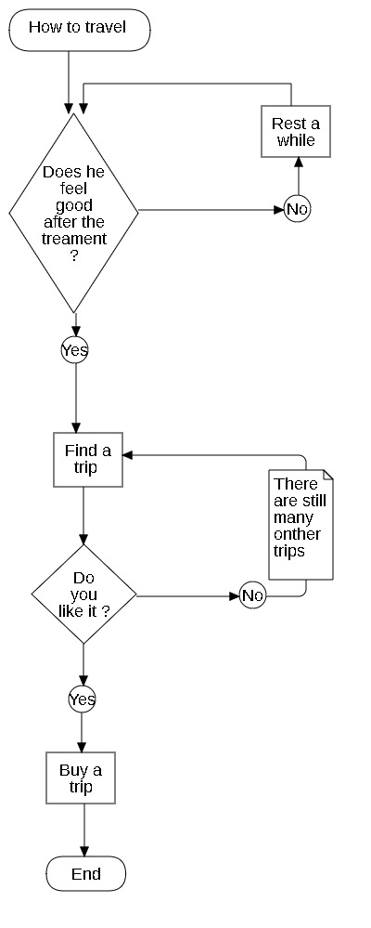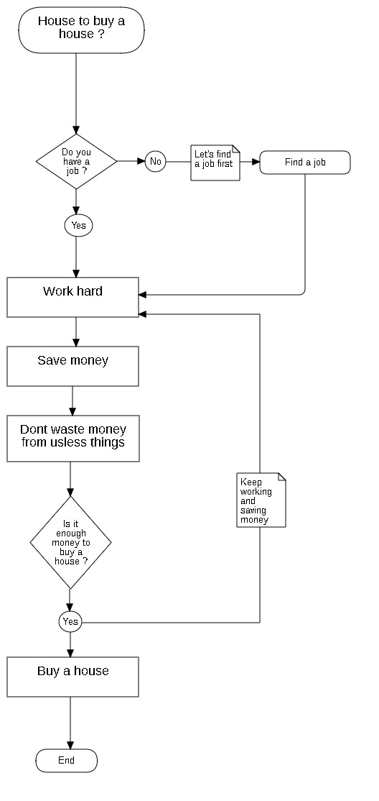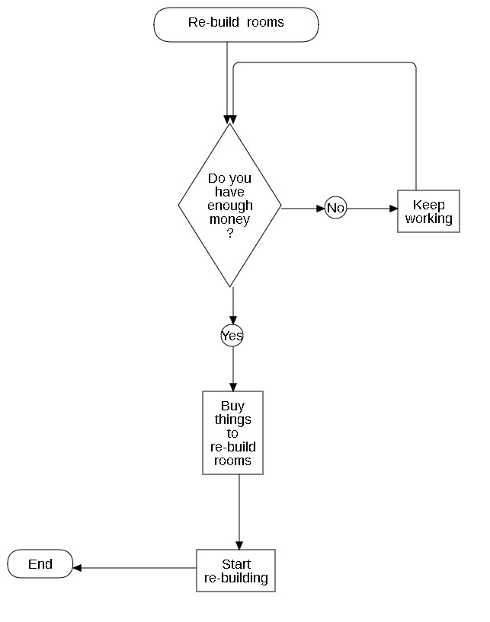

* Show an app-wide information architecture

